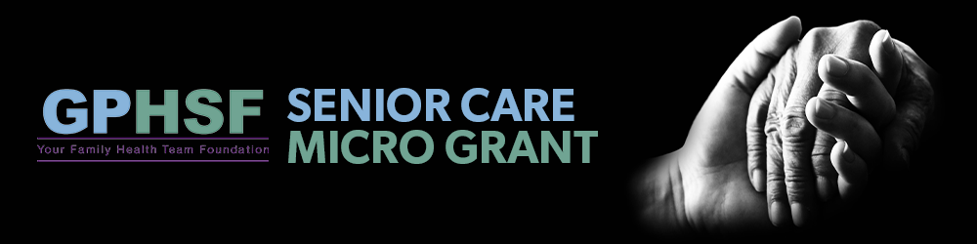

Applications are open to community and not-for-profit organizations, including medical organizations, that run programming and services, or are proposing to run programming and services, within the boundaries of Peterborough City and/or Peterborough Country, Hiawatha First Nation and Curve Lake First Nation.
Proposed projects must be general in scope (inclusive of and impactful on as many people as possible). Project completion must occur within one (1) year of approval unless extension is granted by Greater Peterborough Health Services Foundation.
Maximum of $5000 available for each grant. Two (2) $5000 grants are available. Applications must be received or postmarked by 11:59pm September 30th 2025.
Project timeline and budget must be provided.
For Senior Care grant, type of projects may include.
- Research
- Equipment
- Nutrition
- Physical Activity
- Mental Health
Priority will be given to projects that:
- Have a lasting impact on our community.
- Support emerging needs in our community.
- Improve the quality of life for people in the community.
Please note that all grant applications must be from a not-for-profit charitable organization, with charitable registration number, and located in and/or serving the City or County of Peterborough.

Application Form
Organization:
Charitable Status Number (if applicable):
Date of Application:
Projected start and end date of project:
Name of Program (if applicable):
Contact Name:
Address:
City:
Province:
Postal Code:
Phone:
Email:

Funding
- Type of Funding Requested

- Capital Equipment
- Nutrition
- Physical Activity
- Mental Health
- Research
- Additional funding for previously approved project

- Amount of Funding Requested (Max of $5000)

- In 3 sentences please summarize this project:

- Description of Project: (things to consider including, what is the spend per person impacted in delivery or project, research/planning budget vs. execution, number of staff/volunteers involved, partner organizations for delivery)

- What are the objectives?

- Which of the following does this project impact?

- Health equity
- Health access
- Health promotion

Elaborate how? (previous question)

- Have you been successful in obtaining funding previously for projects, if so, please provide details of outcomes.

- How many unique patients will this impact?

- What is the total project budget?

- How will outcomes/success of this project be measured:

- When can we expect to receive an update on outcomes on this project if funding is approved?

- What is the duration of project and how far will the applied for funding take the project?

- Please list community partners involved in this project:

- Describe how this project is servicing an area of care in the community that is currently not being addressed or requires additional support:

- Should funding be approved, will you be able to provide anecdotal stories with client’s service that we can share with donors?

- Is this program sustainable long term beyond the funding applied for? Please elaborate.

- Have you applied to other funding streams for this project? If so which ones.

Please provide a copy of the following:
1. A project outline and/or supporting material related to the project
2. Any other sources of funding

